**Coding how weight changes affect accuracy**

Now you'll get to change weights in a real network and see how they affect model accuracy!

Have a look at the following neural network: 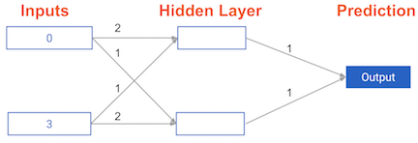

Its weights have been pre-loaded as weights_0. Your task in this exercise is to update a **single** weight in weights_0 to create weights_1, which gives a perfect prediction (in which the predicted value is equal to target_actual: 3).

Use a pen and paper if necessary to experiment with different combinations. You'll use the predict_with_network() function, which takes an array of data as the first argument, and weights as the second argument.

**Instructions**

* Create a dictionary of weights called weights_1 where you have changed **1** weight from weights_0 (You only need to make 1 edit to weights_0 to generate the perfect prediction).
* Obtain predictions with the new weights using the predict_with_network() function with input_data and weights_1.
* Calculate the error for the new weights by subtracting target_actual from model_output_1.